# test 3
# que 1
n = int(input("Enter number : "))
sum = 0
num = 2
while(sum!=n):
for i in range(2,num):
if(num % i == 0):
break
else:
print(num)
sum+=1
num+=1
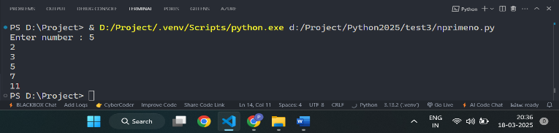
# que 2
n = int(input("Enter number : "))
sum = 0
fact = 1
for i in range( 1, n + 1):
fact = fact * i
sum += i / fact
# total = sum / fact
print("Sum of series of",n,"=",sum)
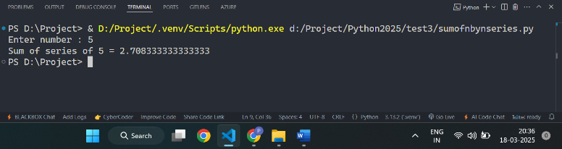
# que 3
n = int(input("Enter number of employees: "))
total_salary_all = 0
for i in range(1, n + 1):
print("Enter basic salary of employee",i,"=",end="")
basic_salary = float(input())
if basic_salary < 20000:
da = 0.10 * basic_salary
ta = 0.12 * basic_salary
hra = 0.15 * basic_salary
else:
da = 0.15 * basic_salary
ta = 0.18 * basic_salary
hra = 0.20 * basic_salary
total_salary = basic_salary + da + ta + hra
total_salary_all += total_salary
print("Total salary of Employee",i,"=",total_salary)
print("Total salary of all employees =",total_salary_all)
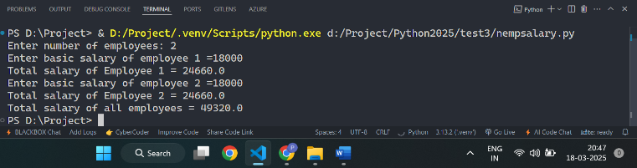
# que 4
n=5
for i in range(0,n):
for j in range(0,n):
if( (i % 2 == 0 and j % 2 == 0) or (i % 2!= 0 and j % 2 != 0) ):
print(1,end ="")
else:
print(0,end ="")
print()
